Hands-on 1:

Data Structures and Algorithms

Exercise 2:
E-commerce Platform Search Function

File name: Product.java

class Product {
int productId;
String productName;
String category;

Product(int productId, String productName, String category) {
this.productId = productId;
this.productName = productName;
this.category = category;
}
}

File Name: SearchDemo.java

import java.util.Arrays;
import java.util.Comparator;

public class SearchDemo {

// Linear Search
public static Product linearSearch(Product[] products, String target) {
for (Product p : products) {
if (p.productName.equalsIgnoreCase(target)) {
return p;
}
}
return null;
}

// Binary Search
public static Product binarySearch(Product[] products, String target) {

int low = 0;
int high = products.length - 1;

while (low <= high) {

int mid = (low + high) / 2;

int compare =
products[mid].productName.compareToIgnoreCase(target);

if (compare == 0) {
return products[mid];
} else if (compare < 0) {
low = mid + 1;
} else {
high = mid - 1;
}
}

return null;
}

public static void main(String[] args) {

Product[] products = {
new Product(101, "Laptop", "Electronics"),
new Product(102, "Mobile", "Electronics"),
new Product(103, "Shoes", "Fashion"),
new Product(104, "Watch", "Accessories")
};

// Linear Search
Product linearResult = linearSearch(products, "Mobile");

System.out.println("Linear Search Result:");

if (linearResult != null) {
System.out.println("Product Found");
System.out.println("ID: " + linearResult.productId);
System.out.println("Name: " + linearResult.productName);
System.out.println("Category: " + linearResult.category);
} else {
System.out.println("Product Not Found");
}

// Sort for Binary Search
Arrays.sort(products,
Comparator.comparing(p -> p.productName));

// Binary Search
Product binaryResult = binarySearch(products, "Watch");

System.out.println("\nBinary Search Result:");

if (binaryResult != null) {
System.out.println("Product Found");
System.out.println("ID: " + binaryResult.productId);
System.out.println("Name: " + binaryResult.productName);
System.out.println("Category: " + binaryResult.category);
} else {
System.out.println("Product Not Found");
}
}
}

Output:

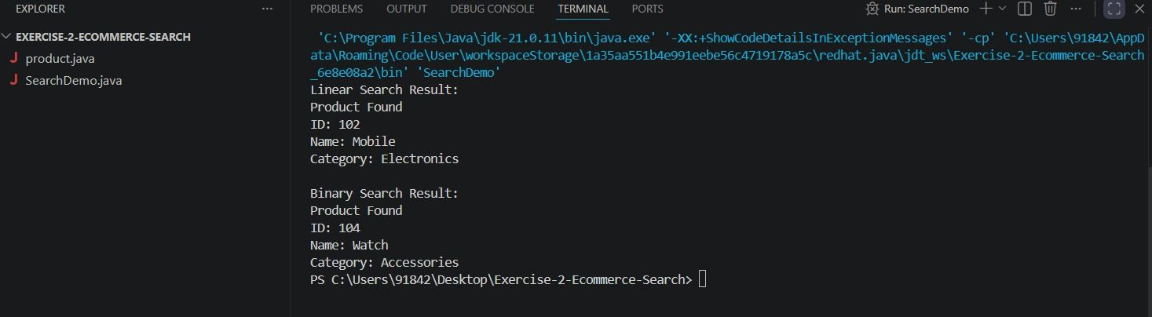

Exercise 7:
Financial Forecasting

File name: FinancialForecast.java

public class FinancialForecast {

// Recursive method to calculate future value
public static double futureValue(double presentValue,
double growthRate,
int years) {

if (years == 0) {
return presentValue;
}

return futureValue(
presentValue * (1 + growthRate),
growthRate,
years - 1
);
}

public static void main(String[] args) {

double presentValue = 10000;
double growthRate = 0.10; // 10%
int years = 5;

double result = futureValue(
presentValue,
growthRate,
years
);

System.out.println("Financial Forecasting Tool");
System.out.println();

System.out.println("Present Value : " + presentValue);
System.out.println("Growth Rate : " + (growthRate * 100) + "%");
System.out.println("Years : " + years);
System.out.println();

System.out.println("Calculating Future Value Using Recursion...");
System.out.println();

System.out.println("Future Value After "
+ years + " Years : " + result);

System.out.println();
System.out.println("Analysis:");
System.out.println("Time Complexity : O(n)");
System.out.println("Space Complexity: O(n)");

System.out.println();
System.out.println("Optimization:");
System.out.println("Use Iteration or Dynamic Programming");
System.out.println("to avoid excessive recursive calls.");
}
}

Output:

